**Novel rabies vaccine vehicle promotes orotopical uptake in wild vampire bats**

**Authors**

Cole Knuese1, Elsa M. Cardenas Canales1, Travis McDevitt-Galles2, Maria Magdalena Ramirez Martinez3, Daniel Limonta1†, Lisa E. Powers2, Daniel P. Walsh4, Daniel G. Streicker5,6, Jorge E. Osorio1, Mostafa Zamanian1, Tonie E. Rocke2*

**Affiliations**

1 School of Veterinary Medicine, University of Wisconsin, Madison, Wisconsin, USA.

2 US Geological Survey National Wildlife Health Center, Madison, Wisconsin, USA.

3 Departamento de Ciencias de la Salud y Ecología Humana, Centro Universitario de la Costa Sur, Universidad de Guadalajara, Autlan, Jalisco, Mexico.

4 U.S. Geological Survey, Montana Cooperative Wildlife Research Unit, Wildlife Biology Program, University of Montana, Missoula, Montana, USA.

5 School of Biodiversity, One Health and Veterinary Medicine, University of Glasgow, Glasgow, UK.

6 MRC-University of Glasgow Centre for Virus Research, Glasgow, UK.

* trocke@usgs.gov

† Present address: College of Medicine, University of Central Florida, Orlando, Florida, USA

**Supplemental Methods**

Methods used for Figures S1-S3 are detailed in the main text.

**Quantitative PCR of stability samples using SYBR Green**

DNA was extracted from our recombinant raccoonpox vaccine candidate expressing a mosaic lyssavirus glycoprotein (RCN-MoG) stored in CMC gel at T=0, and one month and three months of storage at both 4 °C and 23 °C using Zymo Quick DNA Mini Prep kit (Zymo Research, Tustin, California, USA). Tables S1 and S2 were used for preparing the master mix and programming thermocycle conditions. PCR was performed on a CFX Opus 96 Real-Time PCR System (Bio-Rad, Hercules, CA, USA). The primer MoG-F targets the MoG protein, while RCN-R targets the raccoonpox vector.

**Supplementary Table 1. SYBR green quantitative polymerase chain reaction (qPCR) master mix**

|  |  |
| --- | --- |
| **Reagent** | **Volume per sample (μL)** |
| Sso Advanced Universal SYBR Green Master Mix (Bio-Rad, Hercules, California, USA) | 10 |
| MoG-F primer (5’-GGAAGAGTAATATCTTCTTGGGAATC-3’) | 0.5 |
| RCN-R primer (5’CTATAACTATTTTTCCATTGTTTGCCATG-3’) | 0.5 |
| Nuclease free water (Thermo Fisher Scientific, Waltham, MA, USA) | 7 |
| Sample DNA | 2 |
| **Total** | **20** |

**Supplementary Table 2. SYBR green quantitative polymerase chain reaction (qPCR) thermocycle conditions**

|  |  |  |  |
| --- | --- | --- | --- |
| **Step** | **Temperature (**°**C)** | **Time** | **# of Cycles** |
| **Initial Denaturation** | 98 | 3 min | 1 |
| **Denaturation** | 98 | 30 s | 40 |
| **Annealing and Extension** | 60 | 20 s |

**Mitigation measures for capture-related mortalities**

The biomarker transfer studies reported here were performed simultaneously with an ongoing vaccination study (unpublished), requiring a substantial workload during captures. In captures prior to this study, we placed captured bats in individual cloth bags. For this study, we replaced these bags with large wire cages to facilitate airflow, reducing the risk of overheating.

Following the mortality event during the first capture at Jirosto, we obtained additional cages to house a maximum of 30 bats per cage. Only a single cage at a time was brought to the processing station, while the remaining cages were kept inside the entrance of the bat roost, where temperatures were cooler. For the second capture, we also used a small portable fan and a bag of ice to circulate cool air around the cage at the processing station. Ambient temperature and humidity were routinely monitored with a hydrometer-thermometer.

**Biomarker Dosing Study**

**Ethics Statement**

This study was carried out in accordance with protocol #EP200127 approved by the Institutional Animal Care and Use Committee at the USGS National Wildlife Health Center (Madison, WI, USA).

**Study Design**

Twenty-one adult *Eptesicus fuscus* bats (16 female, 5 male) were obtained in collaboration with the Wisconsin Department of Natural Resources in the fall of 2024. Bats were maintained in torpor in an environmental hibernation chamber at the National Wildlife Health Center (Madison, WI). In January 2025, bats were aroused and housed in mesh screen cages (Reptarium, Apogee, Dallas, TX, USA). Bats were fed mealworms (*Tenebrio molitor*) supplemented with vitamin-rich substrate with water provided *ad libitum*. Weights were recorded weekly.

For each dosage level, three bats were treated with each marker. Over the course of the study, no bat received more than three rounds of treatment spaced at least 10 days apart. Individual bats were not fixed into treatment groups of the same marker, rather they could receive doses of different markers. Several females were pregnant at time of study, so treatment groups were determined to minimize handling of these bats. Treated cohorts were placed into separate cages, with a maximum of three treated groups at a time given the allotted space for housing. For each marker, we tested doses of 50 μL (~25 mg/kg) and 100 μL (~50 mg/kg). A dose of 150 μL (~75 mg/kg) was additionally tested for R110 and R101.

A 1% buffer of rhodamine dye was prepared first by dissolving 0.03g of the respective rhodamine powder in 30 μL food-grade ethanol to facilitate dissolution. Then 2.97 mL of 10mM Tris HCl buffer (pH 9.0) was added. Lastly, 0.375 g of CMC stirred in to form a 12.5% gel. RWT is already a liquid, so it was diluted to a final concentration of 1% in Tris buffer.

We collected dorsal hair samples using tweezers at baseline, and 4 h, and 3 days post-dosing. If fluorescence was observed, an additional sample was collected on day 7. Visualization was performed with an SMZ1270 stereomicroscope (Nikon Instruments, Melville, New York, USA) using SMZ1270/800N P-EFLC TRITC AT (540/25 nm / 605/55 nm), SMZ1270/800N P-EFLC GFP LP AT (480/30 nm / 515 nm), and SMZ1270/800N P-EFLC GFP BP AT (480 nm / 535/40 nm) filter sets (Nikon Instruments, Melville, New York, USA).

**Supplementary Table 3. Fluorescence spectra and manufacturer’s information of all rhodamine dyes evaluated for use as biomarkers.**

|  |  |  |  |
| --- | --- | --- | --- |
| **Dye Name** | **Excitation (nm) / Emission (nm)** | **Catalog Number** | **Manufacturer** |
| Rhodamine B (RB) | 543/569 | R6626 | Sigma-Aldrich |
| Rhodamine 110 (R110) | 504/520 | 419070025 | Thermo Fisher Scientific Inc |
| Rhodamine 101 (R101) | 567/588 | 419060010 | Thermo Fisher Scientific Inc |
| Sulforhodamine B (SRB) | 565/586 | A14769.06 | Thermo Fisher Scientific Inc |
| Rhodamine WT (RWT) | 550/588 | 106023 | Kingscote Chemicals |

**Supplemental Results**

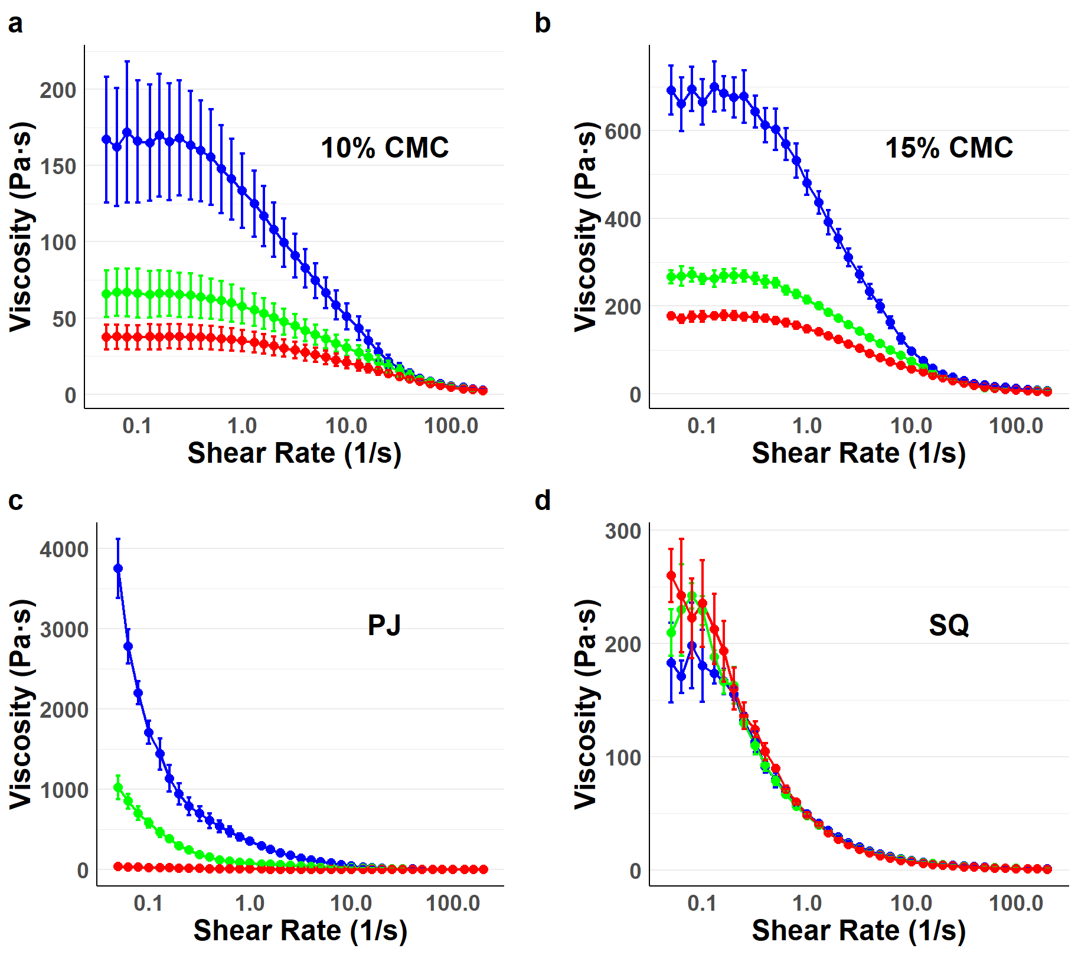

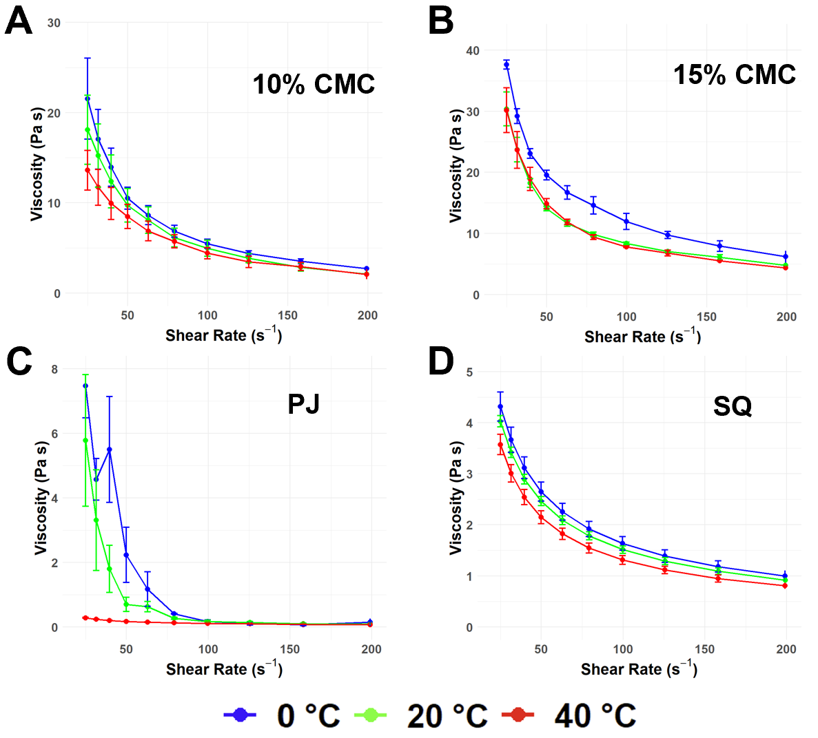

**Supplementary Figure 1. Viscosity profiles of additional gel materials at 0** °**C, 20** °**C and 40** °**C.** A steady rate sweep test was performed with an ARES LS2 Advanced research grade rheometer (TA Instruments, New Castle, Delaware, USA) to measure viscosity of **a)** 10% and **b)** 15% carboxymethyl cellulose (CMC), **c)** petroleum jelly (PJ) and **d)** Silverquine® Animal Wound Dressing Gel (SQ). Error bars represent the standard error of three independent experiments.

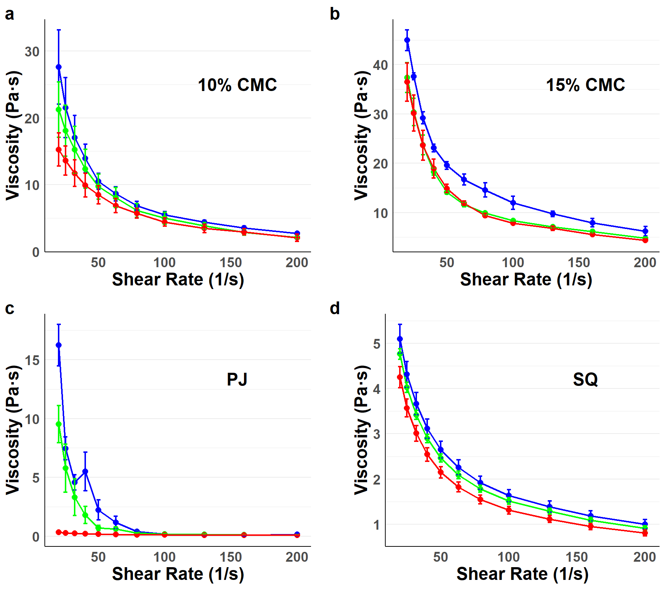



**Supplementary Figure 2. Viscosity profiles of additional gel materials at shear rates from 20 s-1 to 200 s-1 at 0** °**C, 20** °**C and 40** °**C.** A steady rate sweep test was performed with an ARES LS2 Advanced research grade rheometer (TA Instruments, New Castle, Delaware, USA) to measure viscosity of **a)** 10% and **b)** 15% carboxymethyl cellulose (CMC), **c)** petroleum jelly (PJ) and **d)** Silverquine® Animal Wound Dressing Gel (SQ). Error bars represent the standard error of three independent experiments.

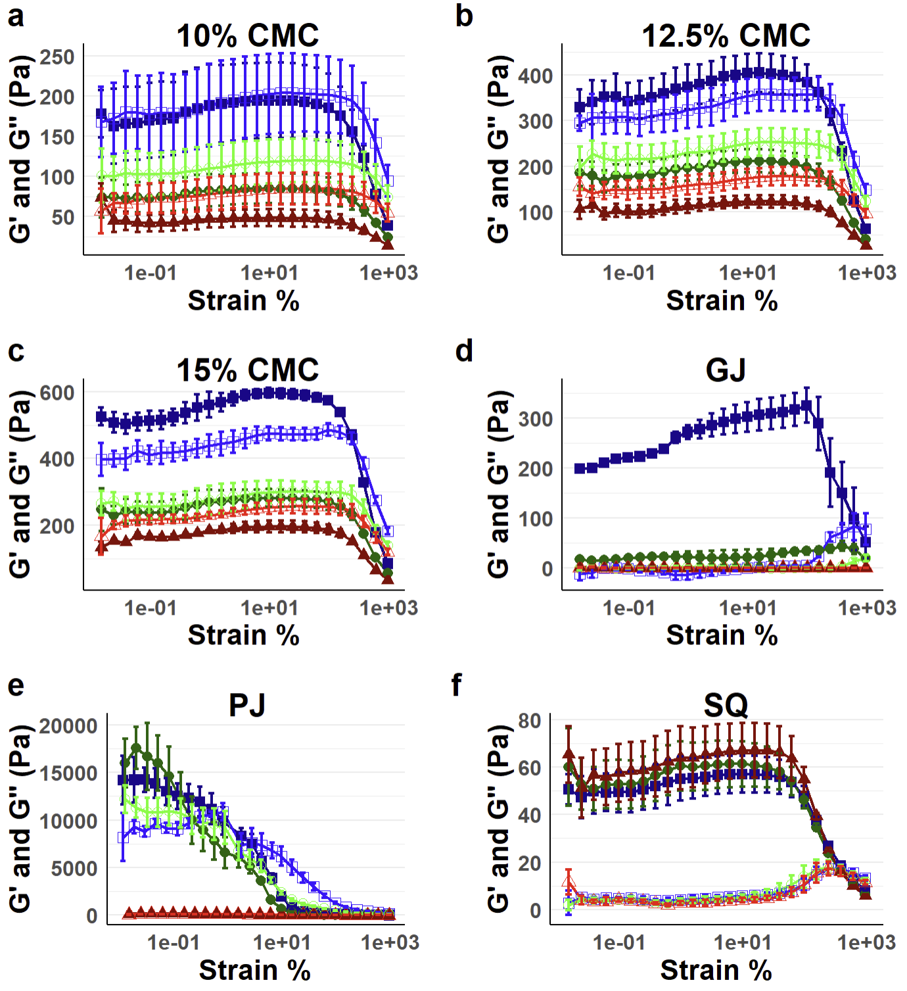

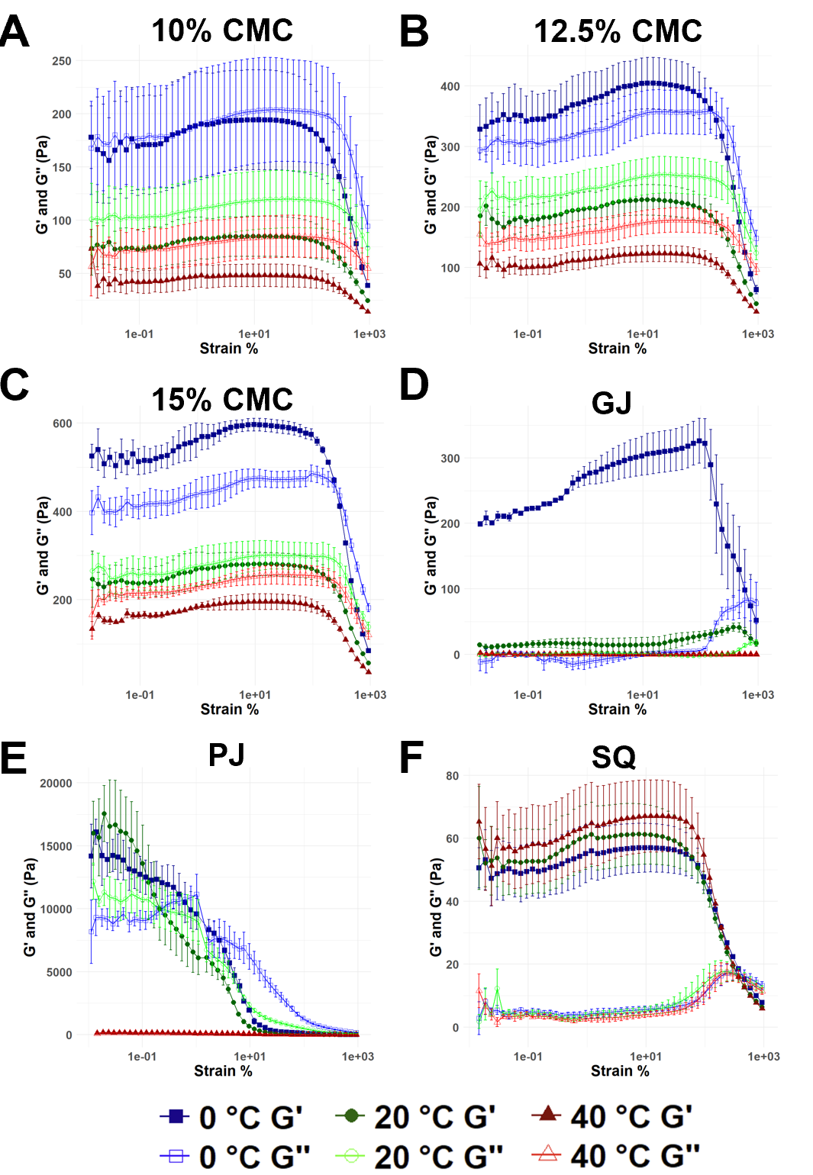

**Supplementary Figure 3. Complete profiles of viscoelastic properties of gel materials at 0** °**C, 20** °**C and 40** °**C.** A dynamic strain sweep test was performed with an ARES LS2 Advanced research grade rheometer (TA Instruments, New Castle, Delaware, USA) to measure viscosity of **a)** 10%, **b)** 12.5 % and **c)** 15% CMC, **d)** glycerin jelly (GJ) **e)** petroleum jelly (PJ) and **f)** Silverquine (SQ). Error bars represent standard error of three independent experiments.

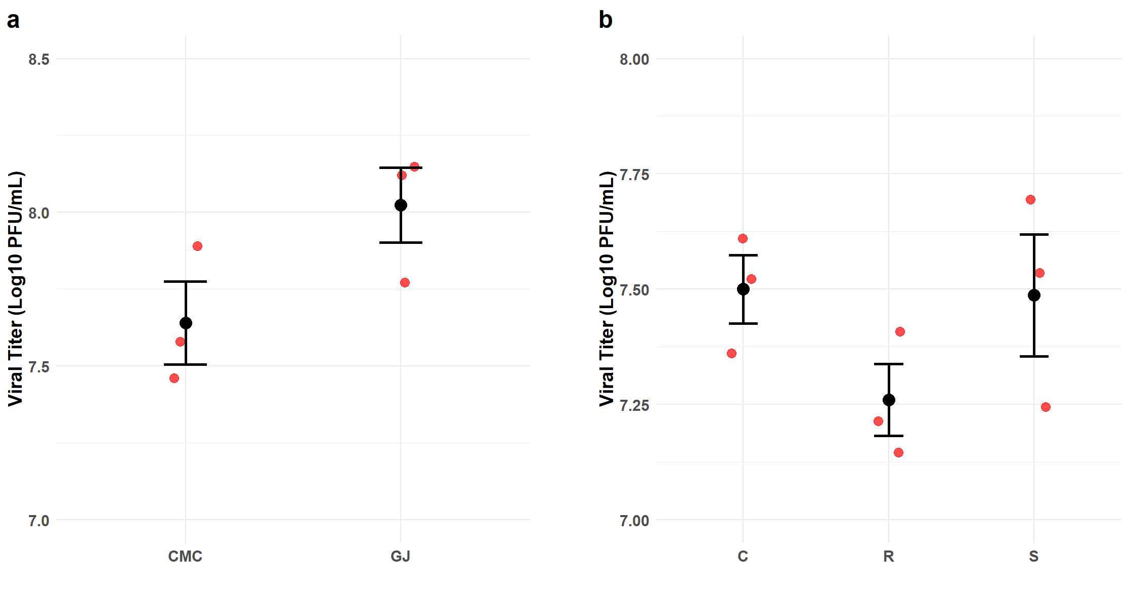

**Supplementary Figure 4. Baseline recovery of a recombinant raccoonpox vaccine expressing a mosaic lyssavirus glycoprotein (RCN-MoG) from stability assay 1 and 2 at T=0. a)** An initial titer of 108 plaque-forming units (PFU)/mL was mixed into 12.5% CMC and GJ and frozen at -80 °C. The gels were thawed, dissolved, and titered by plaque assay on Vero cells (ATCC CCL-81). **b)** Likewise, for the second stability assay, the same initial titer was mixed into formulations C - 12.5% CMC gel, R - 12.5% CMC gel with 0.3% rhodamine B (RB), and S – 12.5% CMC gel with 0.3% RB and 20% sucrose, frozen, dissolved, and titered. Red dots represent independent experiments and error bars represent standard error.

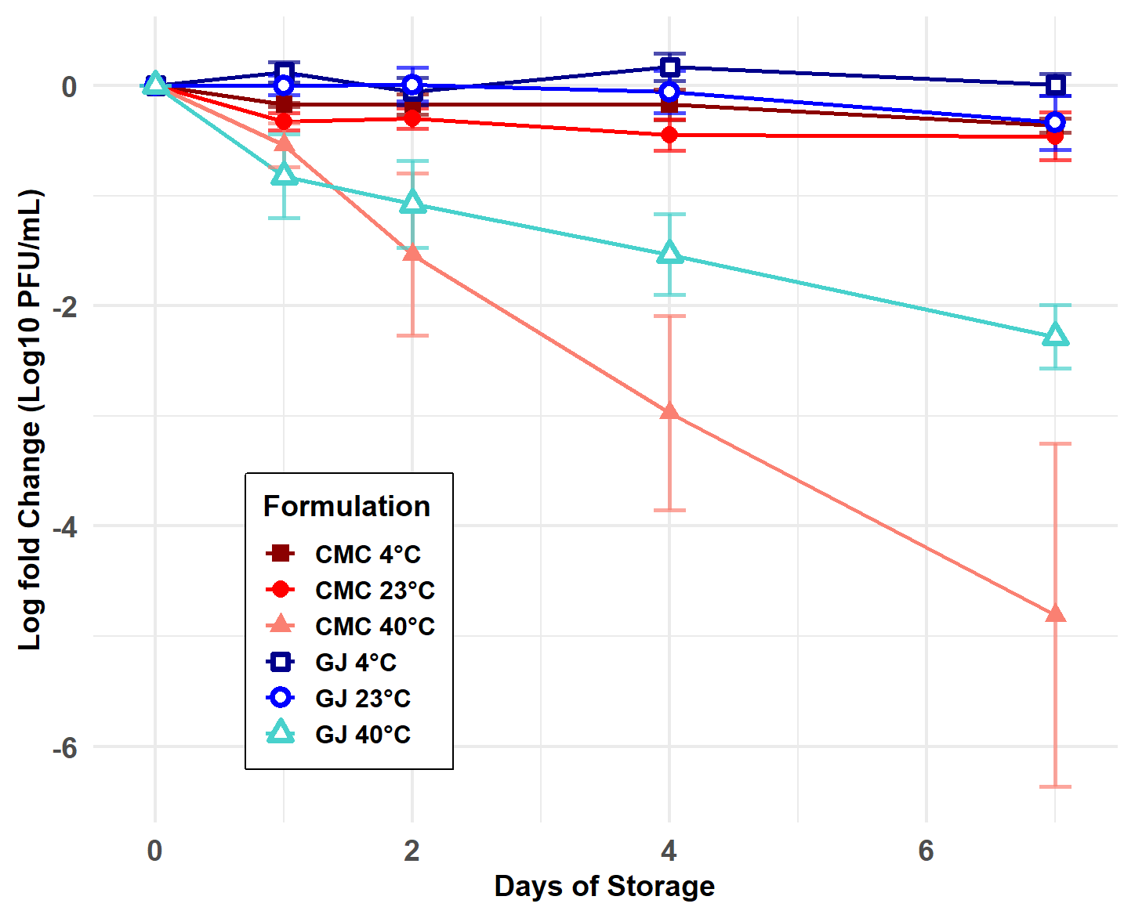

**Supplementary Figure 5. Viral titers of a recombinant raccoonpox vaccine expressing a mosaic lyssavirus glycoprotein (RCN-MoG) measured over the first week of storage in stability assay 1.** A concentration of 108 plaque-forming units (PFU)/mL was mixed into 12.5% carboxymethyl cellulose (CMC) and glycerin jelly (GJ). Aliquots were stored at 4 °C, 23 °C, and 40 °C and tittered by viral plaque assay.

**Supplementary Table 4. Weekly decay rates (log10 PFU/mL) and 95% credible intervals of RCN-MoG viral vaccine titers in Stability Assays 1 and 2.**

|  |  |  |  |  |
| --- | --- | --- | --- | --- |
| **Stability Assay 1** |  |  |  |  |
| **Formulation** | **Temperature (**°C) | **Decay Rate** | **2.5% CrI** | **97.5% CrI** |
| GJ | 4 | -6.438E-04 | -3.596E-02 | 3.453E-02 |
| CMC | 4 | -3.421E-02 | -6.924E-02 | 9.389E-04 |
| GJ | 23 | -1.806E-01 | -2.154E-01 | -1.456E-01 |
| CMC | 23 | -4.630E-01 | -5.375E-01 | -3.867E-01 |
| GJ | 40 | -1.499E+00 | -1.730E+00 | -1.265E+00 |
| CMC | 40 | -3.505E+00 | -4.027E+00 | -2.982E+00 |
| **Stability Assay 2** |  |  |  |  |
| **Formulation** | **Temperature** | **Decay Rate** | **2.5% CrI** | **97.5% CrI** |
| C | 4 | -6.939E-02 | -1.497E-01 | 9.341E-03 |
| R | 4 | -1.293E-01 | -1.993E-01 | -6.085E-02 |
| S | 4 | -7.658E-02 | -1.454E-01 | -6.412E-03 |
| C | 23 | -4.063E-01 | -6.325E-01 | -1.823E-01 |
| R | 23 | -9.383E-01 | -1.161E+00 | -7.097E-01 |
| S | 23 | -4.045E-01 | -4.734E-01 | -3.351E-01 |

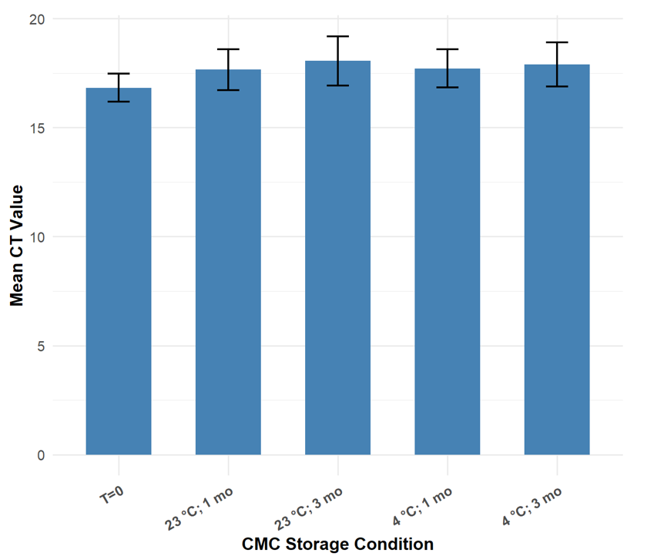

**Supplementary Figure 6. CT values from SYBR Green quantitative PCR measuring DNA stability of a recombinant raccoonpox vaccine expressing a mosaic lyssavirus glycoprotein (RCN-MoG) within 12.5% carboxymethyl cellulose (CMC) gel in samples stored at 4** °**C and 23** °**C for one and three months.** CT values were averaged across results using DNA extracted from all three independent experiments of the RCN-MoG stability assay. Error bars represent the standard error. No statistical comparisons were significant by t-test.

**Hair sampling of bats treated with fluorescent rhodamine dyes**

Most bats treated with a high dose (100 – 150 μL) of R110 showed fluorescence in hair samples (Supplementary Fig. 7). However, fluorescence was brightest at the 4-h timepoint and progressively dimmed at later timepoints. This suggested that R110 could potentially be used as a biomarker, although the fluorescence signal appeared less strong compared to RB. No fluorescence was noted in the hair follicles of bats treated with these three rhodamines at any tested concentration nor timepoint (Supplementary Fig. 8).

It was noted that samples from bats that had ingested RB also fluoresced under the GFP filter (Supplementary Fig. 7). The RB gel itself did not fluoresce in the green channel, suggesting that this effect is not the result of spectral overlap. This overlap effect was not as pronounced in the vampire bat hair samples (Supplementary Fig. 9).

The other tested rhodamines (R101, SRB, and RWT) have similar fluorescence spectra to RB. We hypothesized that their molecular structures could be less likely metabolized into R110, perhaps leading to less overlap in fluorescence with R110. However, little research has been published using these molecules *in vivo*. We discontinued the dosing regimen before the high dose for SRB and RWT due to the absence of fluorescence.

No adverse effects were noted from treatment with any marker. Notably, no signs of taste aversion for R110, R101, SRB, nor RWT were noted at the tested concentration of 1%.

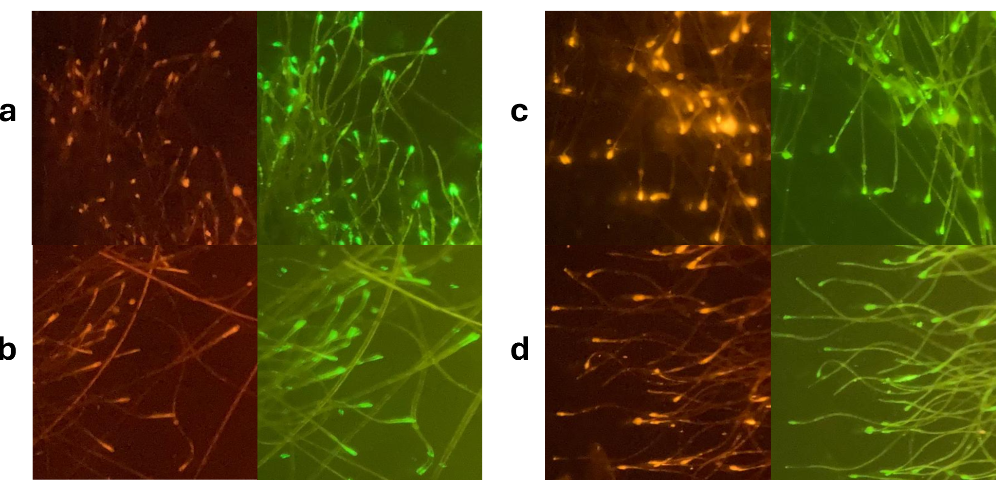

**Supplementary Figure 7. Hair samples of big brown bats (*Eptesicus fuscus*) treated with rhodamine 110 (R110) and rhodamine B (RB).** Hair samples of bats treated with **a)** ahigh dose (150 μL) of R110 collected at 4 h and **b)** 3 days, and **c)** a low dose (50 μL) of RB collected at 4 h, and **d)** 3 days. For each panel, the left image was captured using the SMZ1270/800N P-EFLC TRITC AT (540/25 nm / 605/55 nm) filter and the right image with the SMZ1270/800N P-EFLC GFP LP AT (480/30 nm / 515 nm) filter. Magnification of 12x was used.

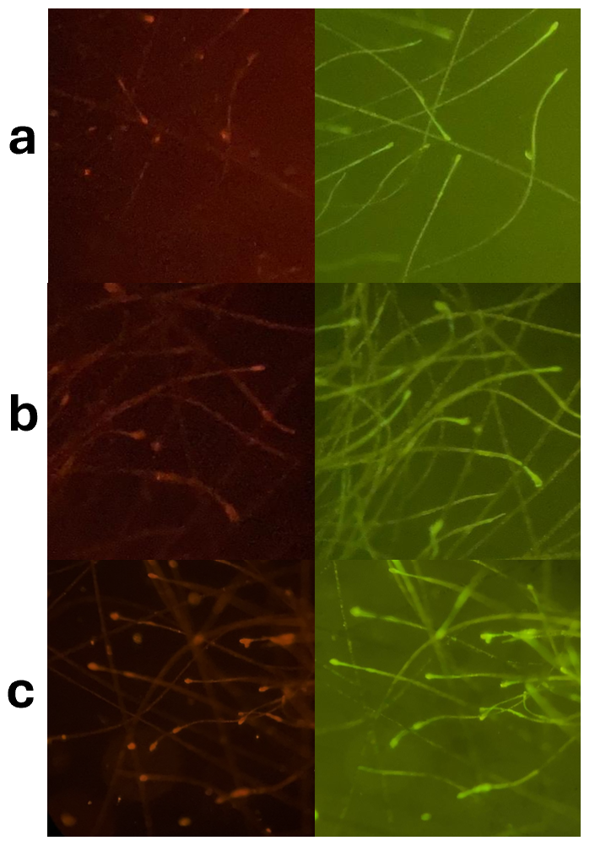

**Supplementary Figure 8. Hair samples of big brown bats (*Eptesicus fuscus*) taken 4 h after treatment with rhodamine 101 (R101), sulforhodamine B (SRB) and rhodamine WT (RWT):** Bats were treated with **a)** ahigh dose (150 μL) of R101, **b)** amedium dose (100 μL) of SRB, and **c)** amedium dose (100 μL) of RWT**.** For each panel, the left image was captured using the SMZ1270/800N P-EFLC TRITC AT (540/25 nm / 605/55 nm) filter and the right image with the SMZ1270/800N P-EFLC GFP LP AT (480/30 nm / 515 nm) filter. Magnification of 12x was used.

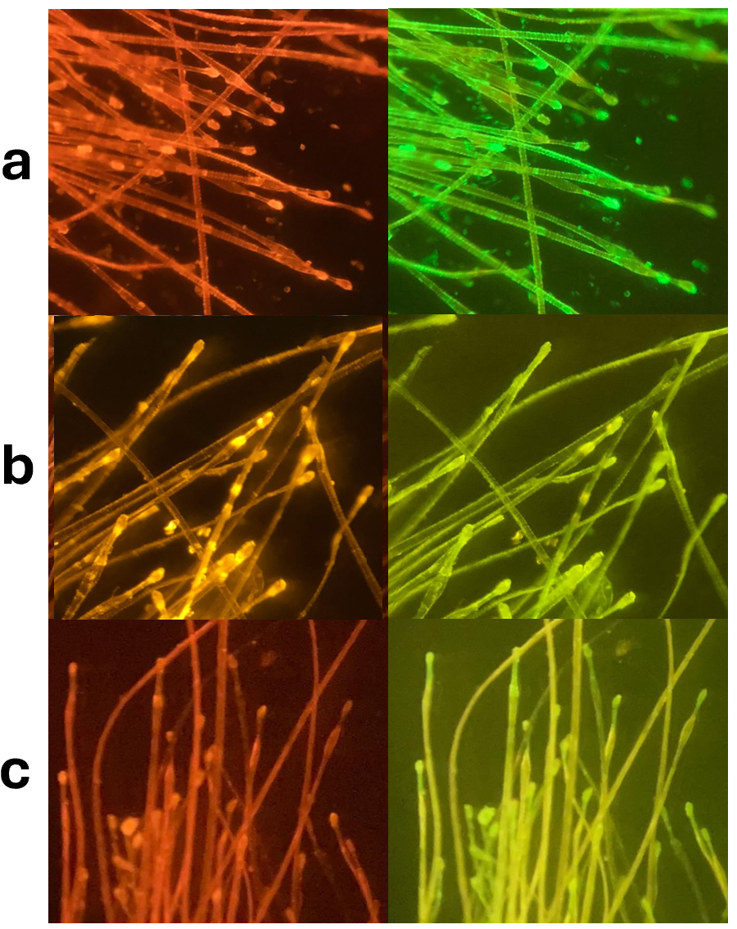

**Supplementary Figure 9. Hair samples of vampire bats (*Desmodus rotundus*) collected in the field five days after topical application of carboxymethyl cellulose gel containing rhodamine 110 (R110) or rhodamine B (RB).** Panels depict **a)** a sample positive for R110, **b)** a sample positive for RB, and **c)** a negative sample. For each panel, the left image was captured using the SMZ1270/800N P-EFLC TRITC AT (540/25 nm / 605/55 nm) filter and the right image with the SMZ1270/800N P-EFLC GFP LP AT (480/30 nm / 515 nm) filter. Magnification of 12x was used. These samples were collected as part of Field Study 2.

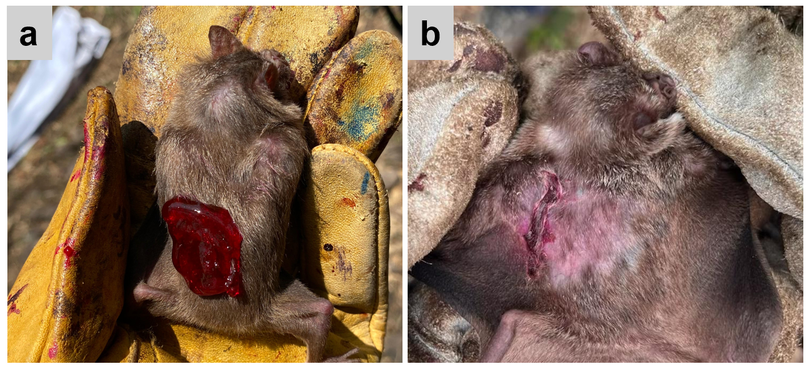

**Supplementary Figure 10. Hair loss associated with topical application of 12.5% carboxymethylcellulose gel with 0.3% rhodamine B. a)** One milliliter of CMC gel was topically applied to the dorsal fur of vampire bats. **b)** Two adult males recaptured 5 days after treatment application showed signs of barbering from dried gel that was not consumed. Across all field studies, 29 other recaptured bats that had received topical treatment showed minimal to no hair loss or staining from the biomarker. This effect could be minimized by applying treatment closer to the shoulders to facilitate self-grooming.